Name: Oladoyinbo David Boluwatife
Department: Computer Science
Matric Number: 240502088
Course: IFT203
Assignment Answer:

- Observing the requests and responses in the network tab, the HTTP status code is 200, MIME type of files (text/html, text/css)
Short explanation: When I enter the URL and press Enter, the browser sends an HTTP GET request to the server. The server processes the request and returns an HTTP response with a status code (200) and the requested resource. The browser receives the HTML file (MIME: text/html), parses it, and discovers linked assets (CSS, images). It then sends additional requests for each asset, which the server responds to with appropriate MIME types. Finally, the browser renders the complete page using HTML structure, CSS styling, and embedded media.
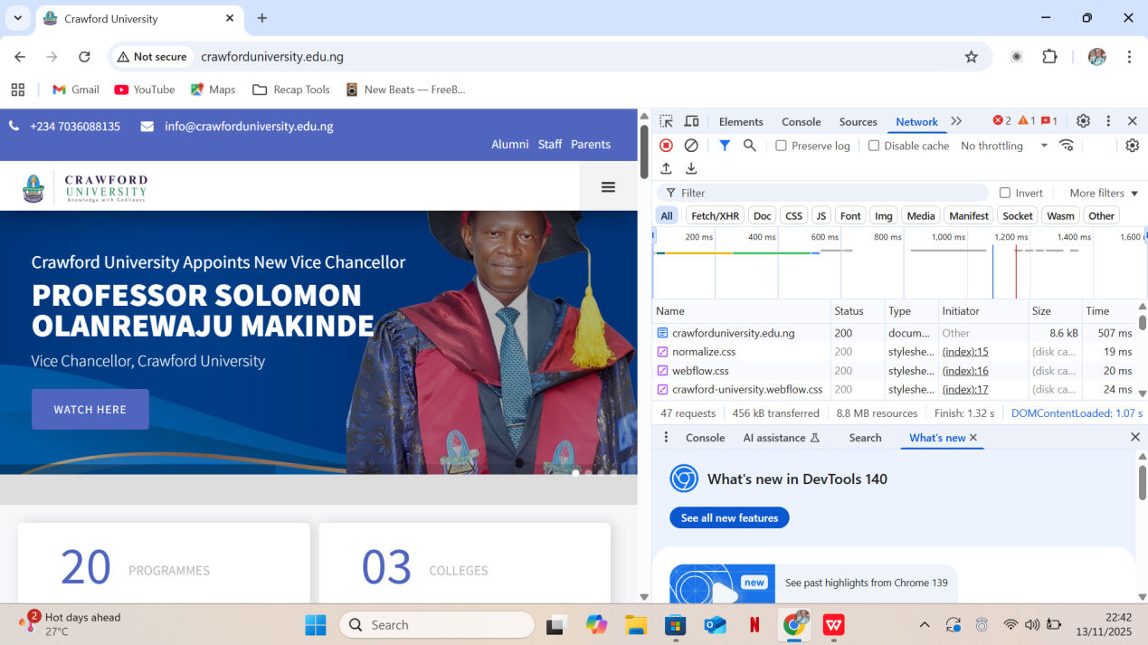

After visiting the elements tab, I realised the structure of the page is HTML, CSS, JS and PHP.

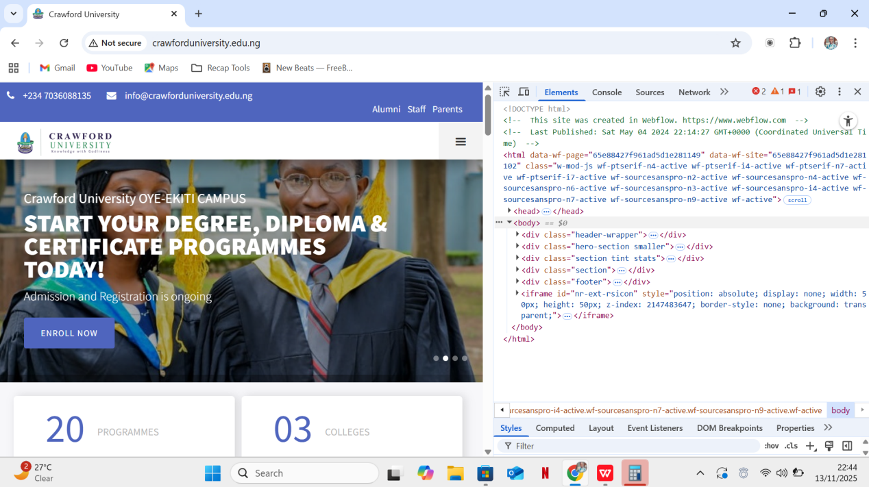

- SHORT QUIZ

- Differentiate between the internet and the world wide web;
- Internet: A global network of interconnected computers using TCP/IP protocols to exchange data (email, file transfer, etc.).
- World Wide Web (WWW): An information system on the Internet that uses HTTP/HTTPS and hypertext (HTML links) to access interlinked documents via browsers.
- Mention and explain why two protocols make the internet work;
· TCP (Transmission Control Protocol): Ensures reliable, ordered, and error-checked delivery of data packets between devices.
· IP (Internet Protocol): Handles addressing and routing of packets across networks using IP addresses (e.g., IPv4/IPv6).
- List and explain three key components of web architecture;
· Client (Web Browser): Software (e.g., Chrome) that sends HTTP requests and renders responses.
· Server (Web Server): Hardware/software (e.g., Apache, Nginx) that stores web files and responds to client requests.
· HTTP/HTTPS Protocol: Rules for communication between client and server, including request methods (GET, POST) and status codes.
- Who is credited with inventing the World Wide Web, and in what year?
Tim Berners-Lee is credited with inventing the World Wide Web in 1989 (proposed the system while at CERN).
- In your own words, describe the role of a web browser;
A web browser is a user-friendly tool that fetches web pages from servers, interprets HTML, CSS, and JavaScript, and displays interactive content on your screen. It acts as a translator between human users and the technical language of the web.

- REFLECTION TASK
My daily life revolves around the Internet and World Wide Web. I use WhatsApp and Snapchat to communicate, Google Chrome to access Crawford University’s portal for results. Online banking, Instagram, and many more websites all run on the web. Without the Internet’s connectivity and the World Wide Web’s hyperlinked structure, I’d lose instant access to information, collaboration tools, and essential services, making routine tasks slow and disconnected.

